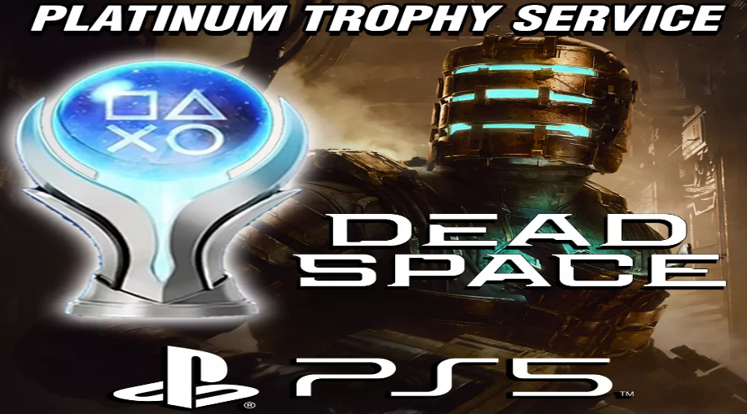

*Dead Space Remake:*

1️.**Complete Visual & Audio Overhaul**

* **Next-gen graphics, dynamic lighting, and 3D audio** enhance the **atmosphere and horror**.

2️. **Seamless, No-Loading Horror Experience**

* The entire game is presented **without cuts or loading screens**, making it more immersive.

3️. **Classic Dismemberment Combat with Realistic Damage**

* The **"Peeling System"** shows **flesh and bones tearing away** as you shoot Necromorphs.

4️. **Expanded Story & Fully Voiced Isaac Clarke**

* Isaac **now speaks** and interacts more with other characters, adding **depth to the story**.

5️. **Improved Zero-Gravity Exploration**

* **New movement mechanics in zero-G** let Isaac **fly freely** rather than jumping between surfaces.

Would you like **survival tips, best weapons, or secret locations in the game?** 🎮👾🚀